- Create VPC

Created vpc using script

resource "aws_vpc" "main" {
cidr_block = "10.0.0.0/16"
tags = {
Name = "main-vpc"
}
}

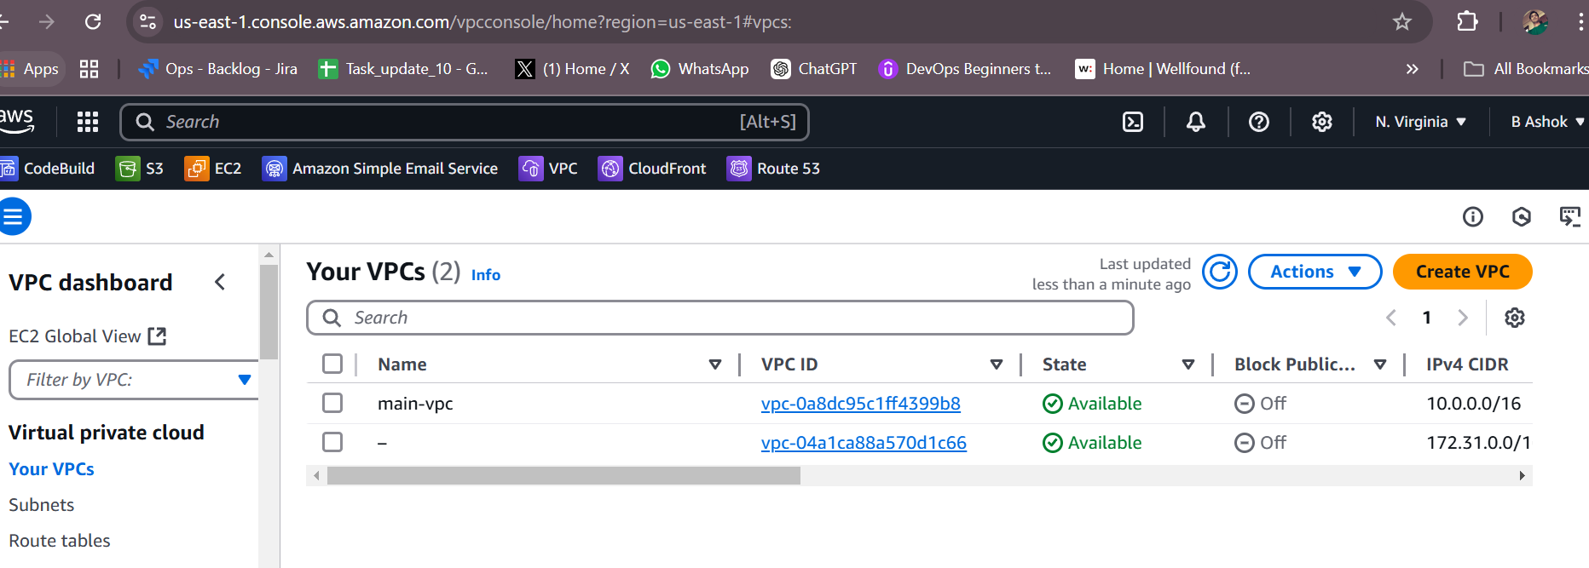

- Create Internet gateway

resource "aws_internet_gateway" "igw" {
vpc_id = aws_vpc.main.id
tags = {
Name = "main-igw"
}
}

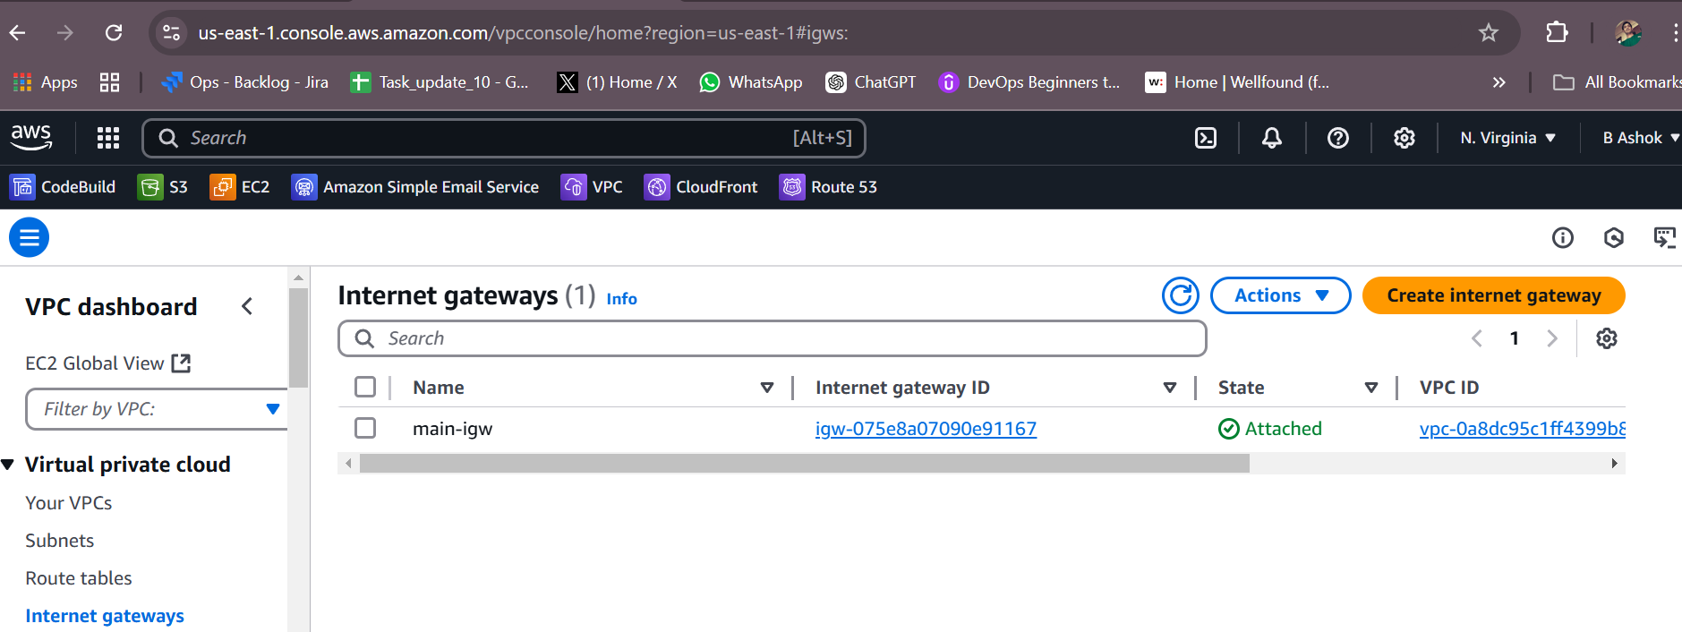

- Create Custom Route Table
resource "aws_route_table" "main" {
vpc_id = aws_vpc.main.id
route {
cidr_block = "0.0.0.0/0"
gateway_id = aws_internet_gateway.igw.id
}
tags = {
Name = "main-route-table"
}
}

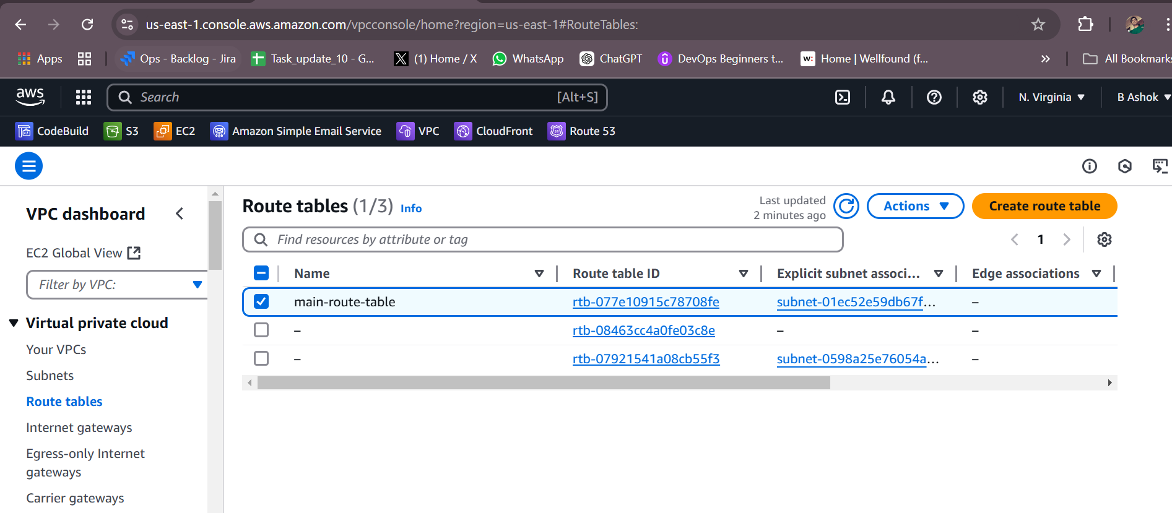

- Create Subnet

resource "aws_subnet" "main" {
vpc_id = aws_vpc.main.id
cidr_block = "10.0.1.0/24"
tags = {
Name = "main"
}
}

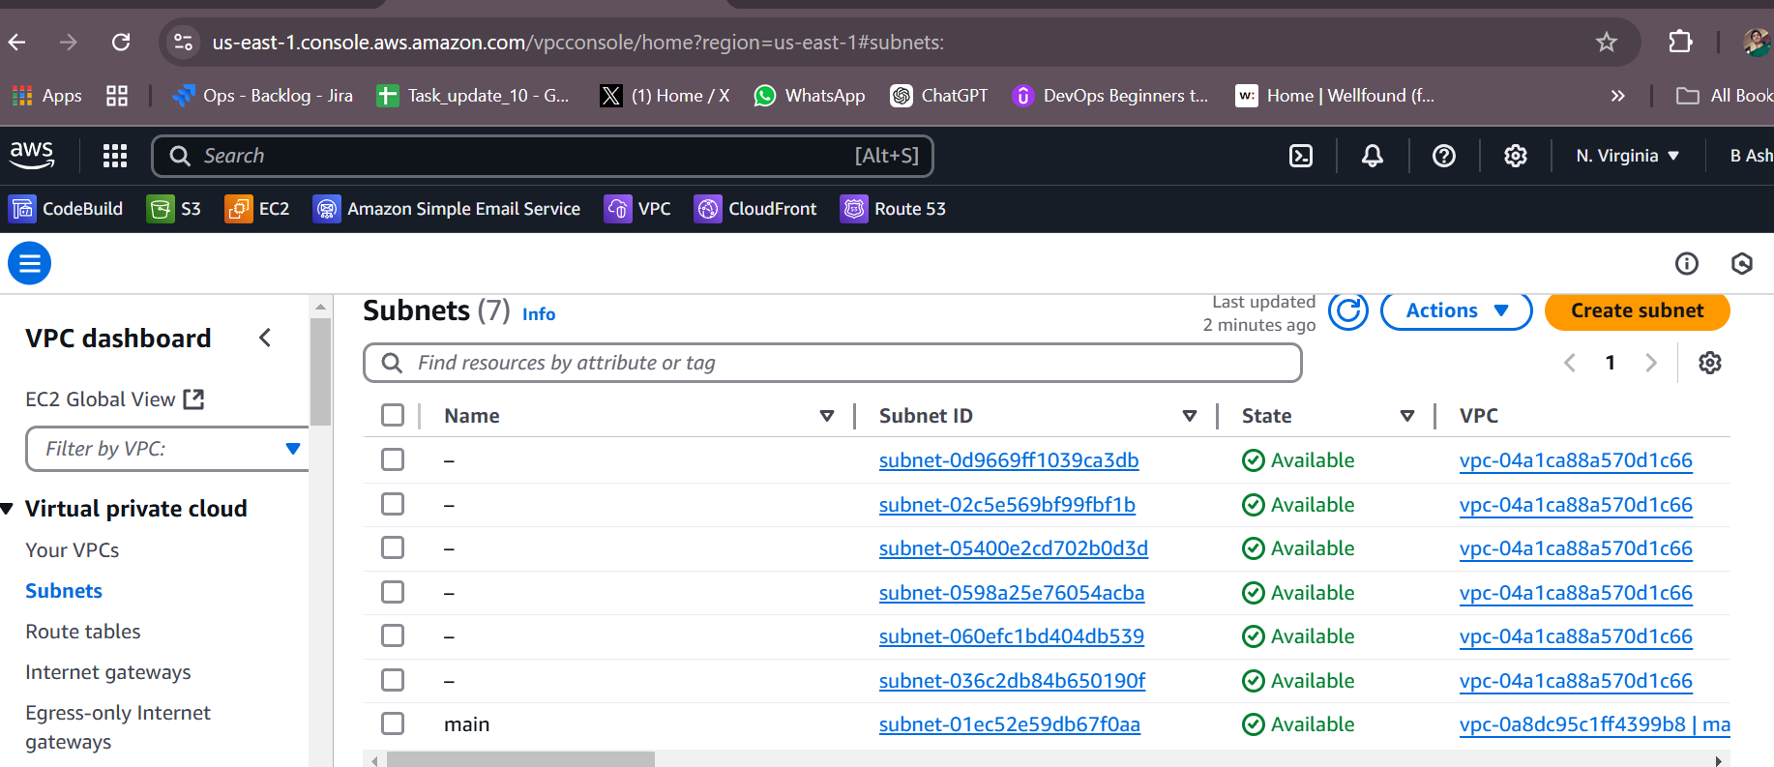

- Associate subnet with Route Table

resource "aws_route_table_association" "a" {
subnet_id = aws_subnet.main.id
route_table_id = aws_route_table.main.id
}
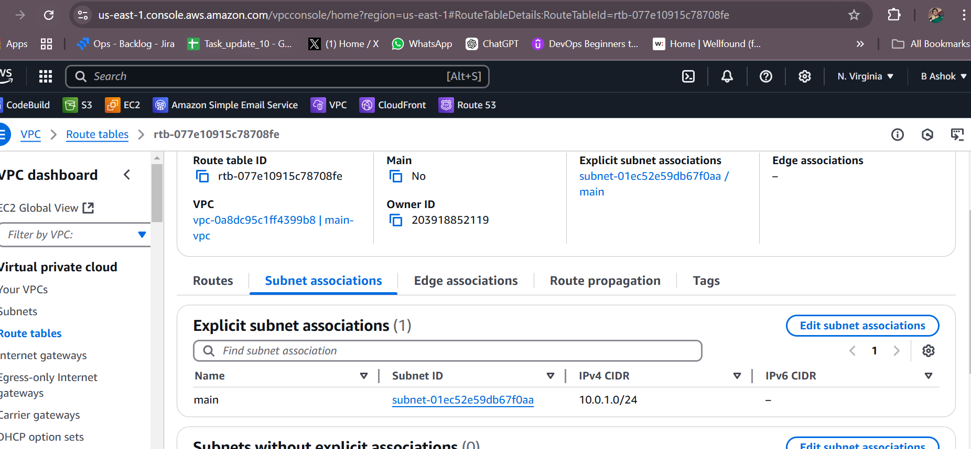

- Create Security Group to allow port 22.80,443

resource "aws_security_group" "main" {
vpc_id = aws_vpc.main.id

ingress {
from_port = 22
to_port = 22
protocol = "tcp"
cidr_blocks = ["0.0.0.0/0"]
}

ingress {
from_port = 80
to_port = 80
protocol = "tcp"
cidr_blocks = ["0.0.0.0/0"]
}

ingress {
from_port = 443
to_port = 443
protocol = "tcp"
cidr_blocks = ["0.0.0.0/0"]
}

egress {
from_port = 0
to_port = 0
protocol = "-1"
cidr_blocks = ["0.0.0.0/0"]
}

tags = {
Name = "main-security-group"
}
}
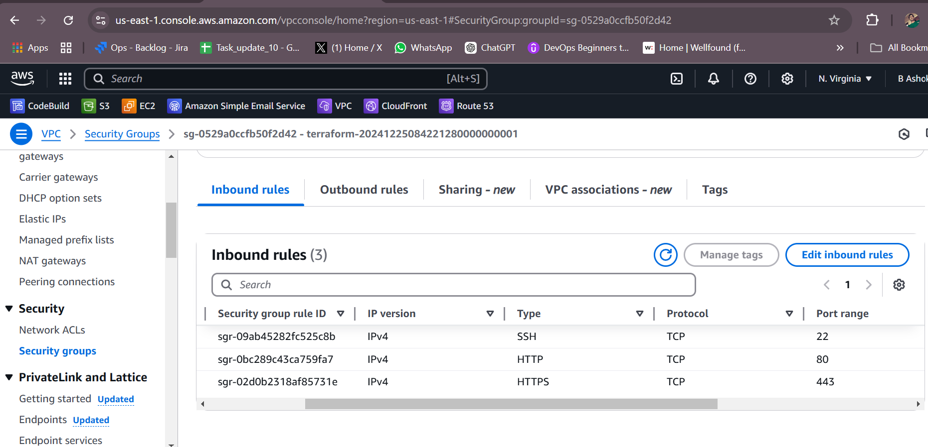

- Create a network interface with an ip in the subnet that was created in step 4

resource "aws_network_interface" "ashok-ni" {
subnet_id = aws_subnet.main.id
security_groups = [aws_security_group.main.id]
private_ips = ["10.0.1.10"]

}
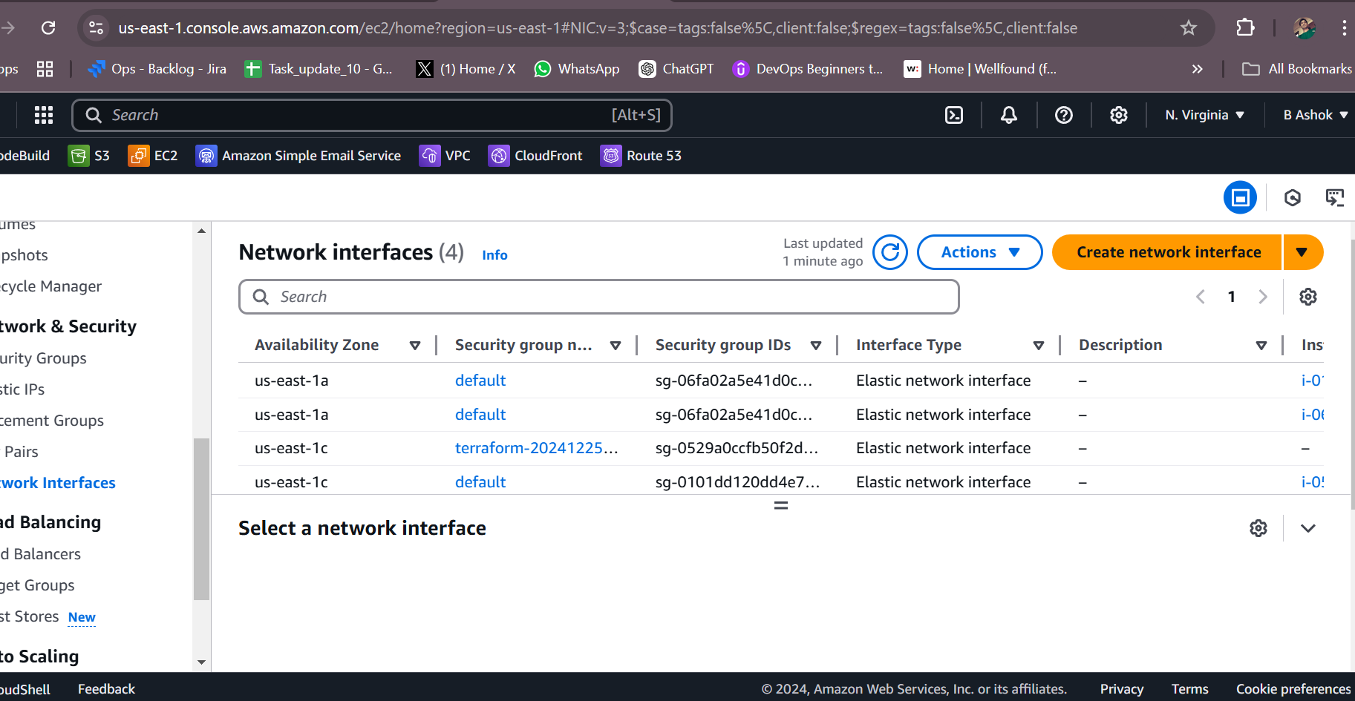

- Assign an elastic IP to the network interface created in step 7

resource "aws_eip" "eip" {
network_interface = aws_network_interface.ashok-ni.id
tags = {
Name = "my-elastic-ip-01"
}
}
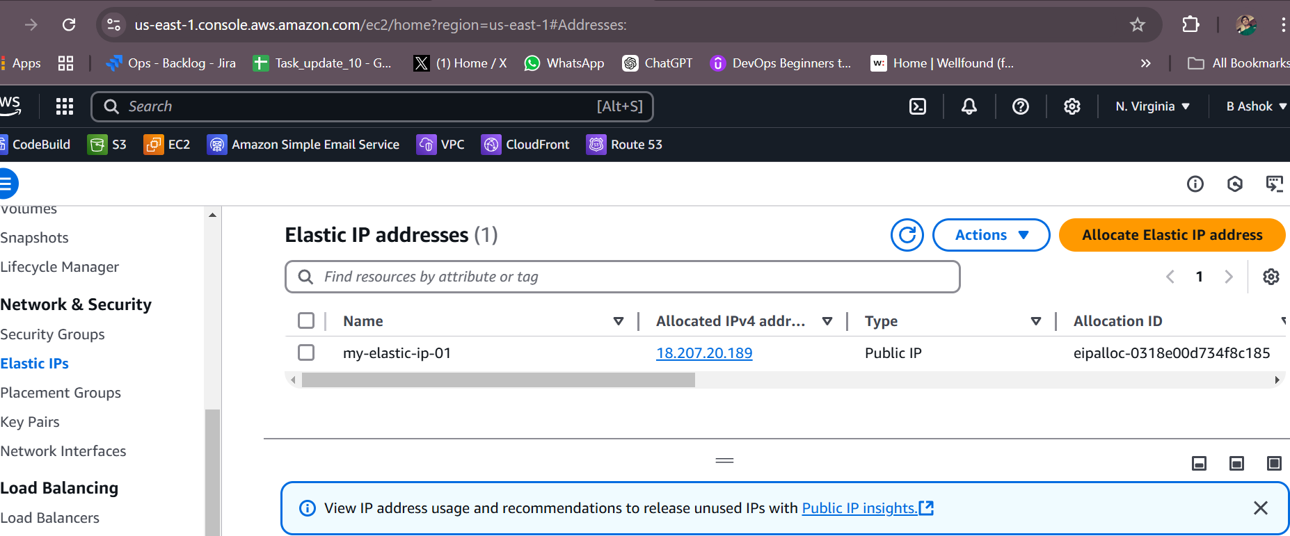

- Create Ubuntu server and install/enable apache2.

resource "aws_instance" "ubuntu" {
ami = "ami-01816d07b1128cd2d"
instance_type = "t2.micro"
subnet_id = aws_subnet.main.id

user_data = <<-EOF
#!/bin/bash
apt-get update
apt-get install -y apache2
systemctl enable apache2
systemctl start apache2
EOF

}
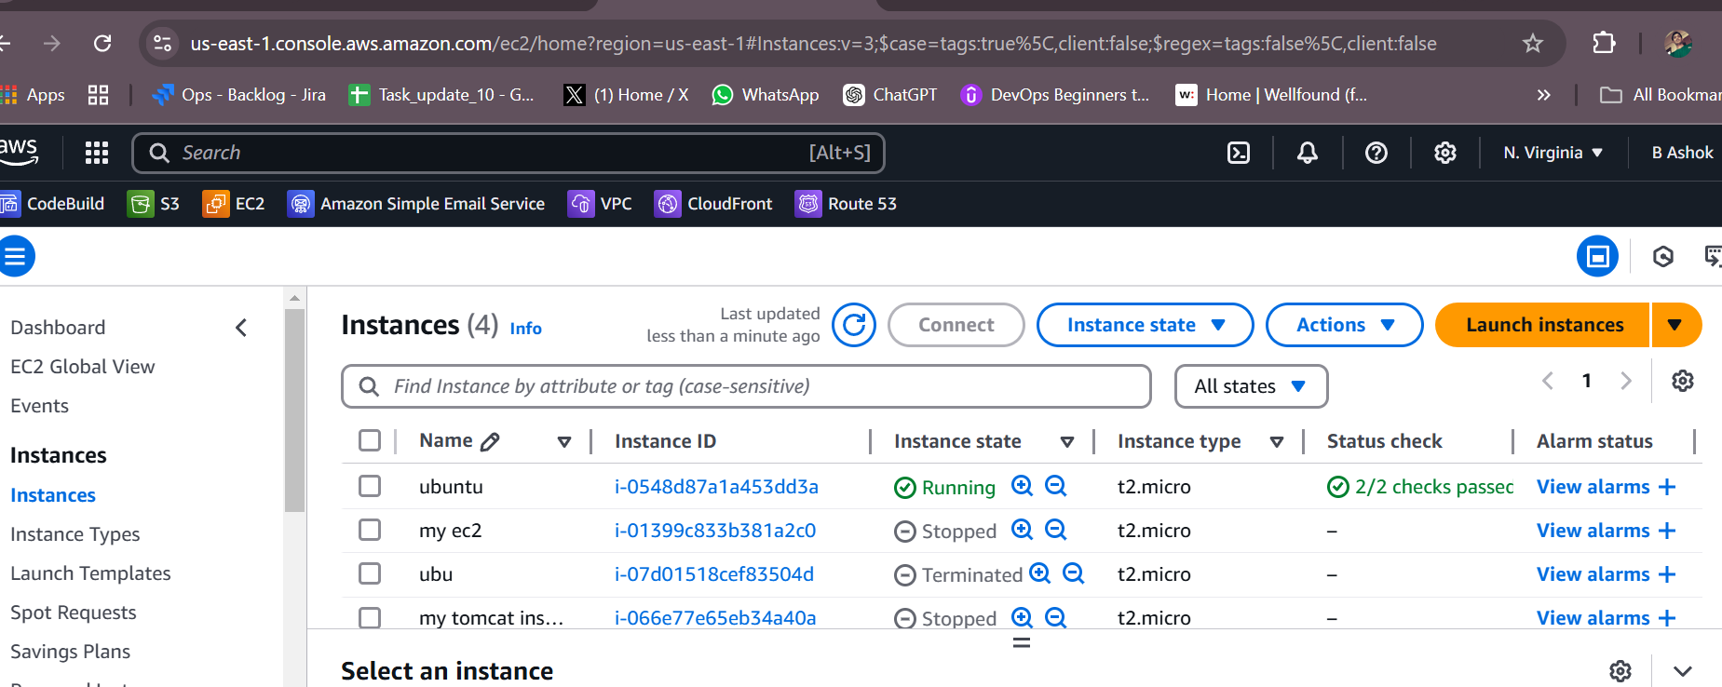

provider "aws" {
region = "us-east-1"
}

terraform {
backend "s3" {
bucket = "your-terraform-state-bucket004"
key = "terraform/state"
region = "us-east-1"
dynamodb_table = "terraform-locks"
}
}
